Colorful Day

(Names)

Business Plan:

Our company’s name is Colorful Day and the service we offer will be a variety of flowers and balloons. Our location will be in the Round Rock/Austin area with the competition of the shops 620 Florist and Floral Fabulous. We can be found in a large vehicle that will house our shop and we will park near parks and we will have a specific rotation of the parks we are located at that can be found in the advertisements. We provide flowers for anything from a grand assortment at an event to a simple bouquet for a loved one. We even offer balloons for parties for children and other events. To gather more attention, we will have complimentary lemonade and cookies for all the customers on Saturdays. We will also have a phone number and email that any possible customers can reach us at for more information.
Our hours will be from 8 to 5 Monday through Saturday and we will be closed on Sundays. We will also start off with just the managers working in the flower truck, and if needed in the future, we will hire more employees to work shifts in the truck. If we do require employees, we will look for knowledge of flowers and whether or not they have people skills. The managers will share the daily responsibility of keeping the truck clean and serving the customers. Every morning they will check any emails and social media to keep an eye on possible competition. Every afternoon after closing, they will analyze company budget, expenses and revenue as well as compile and analyze any other financial information. Then every Monday, they will have to examine the flower truck for any safety hazards and to check everything is running smoothly.
Our plan is to start off with a billboard advertisement to gather attention for a few months. Then after a few months to minimize costs, we will remove the billboard advertisement and just have flyers around the city and ads in magazines. Our target customers will be anyone who desires flowers for any occasion as well as any person walking by the flower truck. Outside the flower truck will be pictures of any possible flower and its price, as well as the types of balloons and their prices. One of the managers will also be outside the truck to help the customers and there will be a few flower arrangements on display for the customers to view.

Financial Report:

Balance Sheet:

Assets: Liabilities:
Cash 50,000 Loan 33,000
Inventory 15,000
Property 20,000
Equipment 10,000 Net Worth:
Owner’s Equity 62,000

Total Assets 95,000 = Total Liabilities and Net Worth 95,000

Income Statement:

Total Revenue (sales) 70,000
Cost of Goods Sold 15,000

Net Sales 55,000

Operating Expenses (per month)

Salaries 800
Loan Payment 300
Rent 700
Advertising 400
Supplies 700
Utilities 600
Phone 40
Insurance 50
Repairs/Maintenance 700
Auto/Truck 400
Licenses/Fees 50

-4,740

Net Income = 50,260

Income Taxes - 15,078

Net Profit =35,182

Profit per Partner -17,591

Interview- May's Street Boutique

How did you begin your business?

“The idea started with me and a friend who wanted to sell clothing at a decent price, but having good quality. Our business took hold and now we sell home goods, and even have a men’s department.”

How many years have you had your business?

“We opened August 2013, so about 3 years.”

What were the unexpected challenges you encountered starting up your business?

“Unforeseen expenses, Logistic consistency, Fraud, motivation, and loneliness.”

What kinds of problems do you deal with in the daily operation of your business?

“Staying organized, and making sure the employees are taking care of all their responsibilities.”

What do you find most rewarding about owning your own business?

“Amidst all the struggles and challenges and the difficulty face at the beginning. At the end of the day I can feel genuinely that my exhaustion has been used and amounted towards one of my greatest creations.”

As a small business owner what advantages do you feel you have over large corporations?

“The primary benefit is being able to have personalized relationships with the day to day customers that arrive. Customers that have a good experience and enjoy the ambience will return to the shop. We see a lot of familiar faces.”

What advice would you give to someone thinking of starting his or her own business?

“Even though the beginning may be extremely taxing, once you are more developed you will begin to see the incredible benefits, and the rewards of having created something successful.”

What was your deciding factor for starting the business?

“I always new I wanted to have my own business, it was just a matter of when and what.”

What do you enjoy the most about your shop?

“Getting to see the familiar faces every day coming in and out. I see that I have created a place where people feel comfortable and happy, to come and take a look around or to buy a new shirt or necklace.”

Layout of Shop

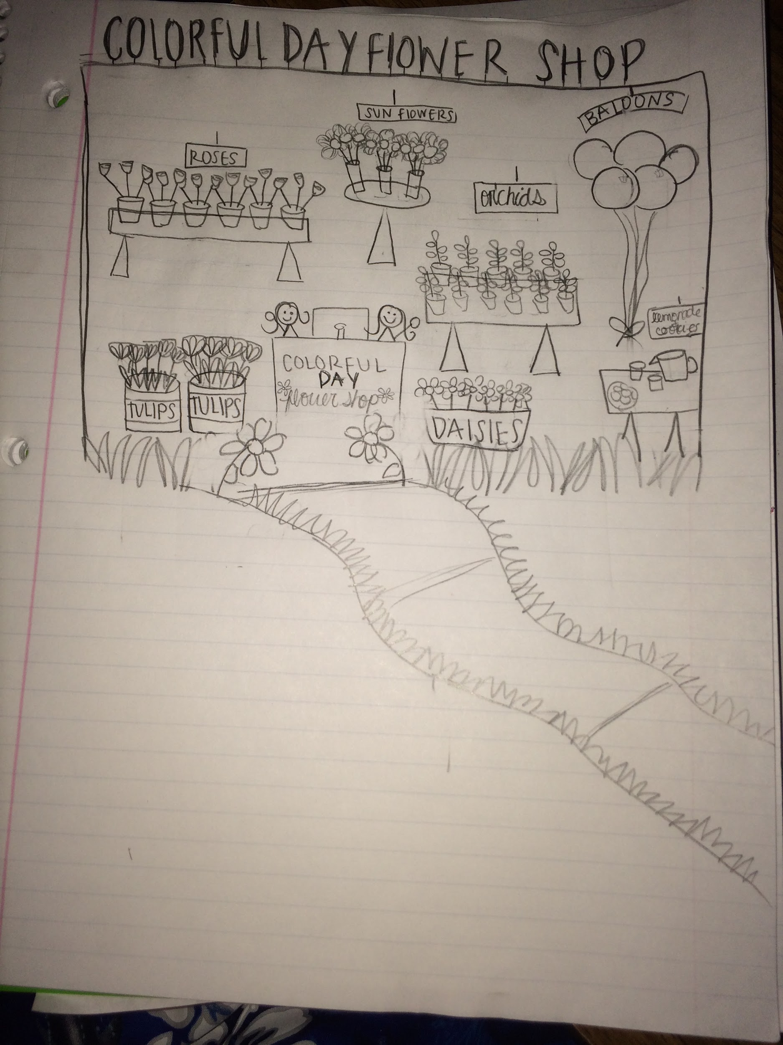

Business Card

Logo

